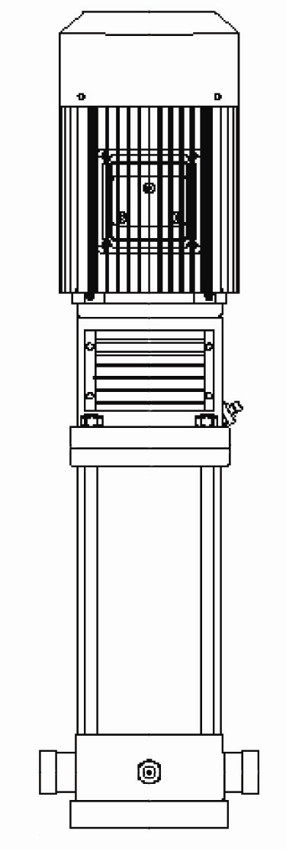

PRODUCT BULLETINMUNICIPALCOMMERCIALINDUSTRIAL
MODEL VM VERTICAL MULTISTAGEQuench Water, Transfer, CirculationHVAC, Booster, Fire Jockey Pump,Process, Transfer,
Filter Backwash, Reverse OsmosisSupply Water, Boiler FeedWash Systems
PRODUCT BULLETIN
MODEL VM VERTICAL MULTISTAGE
Bulletin 470VM
Edition 1

American-Marsh Model VM Vertical Multistage pumps can be used in a variety of industrial, municipal, commercial, mining and agricultural applications. The VM product line is available in standard construction with cast iron suction and motor bracket or in all stainless steel construction. These pumps can be used in the package boiler feed market, used as jockey pumps in the fire protection market or as wash down pumps in the food industry. The VM product line is available in four sizes up to 100 GPM and heads up to nearly 900 Feet. To minimize footprint dimensions in the field the VM models feature inline suction and discharge connections that allow for minimum impact while in service. All models feature a removable and replaceable stack assembly for quick service.

Material Specifications
PART | CONSTRUCTION
PART | STANDARD FITTED | ALL STAINLESS STEEL
Motor Top Bracket | Cast Iron | Stainless Steel
Motor Bottom Bracket | Cast Iron | Stainless Steel
Impeller | Stainless Steel | Stainless Steel
Shaft | Stainless Steel | Stainless Steel
Diffuser | Stainless Steel | Stainless Steel
O-Rings | Viton | Viton
Mechanical Seal | Carbon/Ceramic/Buna | Carbon/Ceramic/Buna

MODEL VM SPECIFICATIONS

Pump Base: The pump base is constructed of high tensile cast iron or other stainless stee material. It is carefully and accurately proportioned to permit smooth flow and to convert high velocity energy of the fluid as it leaves the impeller into pressure. Suction and discharge nozzles are casted integral and are of the inline configuration. Nozzles are available in either a victaulic connection or ANSI flanged connections. All VM models feature a 300 psi case working pressure. Necessary vent and drain openings are provided.

Impeller: The impeller is of the end suction type, stamped and welded of stainless steel. All impellers are balanced prior to assembly. VM models are available in configurations from 2 through 18 stages.

Diffusers: The diffuser is constructed of stamped and welded stainless steel. All diffusers are register connected to the suction, discharge and other stages within the pump to minimize internal recirculation losses.

Mechanical Seal: The mechanical seal assembly is of the cartridge design and is designed to be removed and reinstalled in the pump quickly and efficiently.

Seal Chamber: The seal chamber is sized for a standard, front loading mechanical seal. The mechanical seal is constructed of a carbon rotary face, a ceramic stationary face and buna elastomers standard.

Motor: All VM models utilize standard, stocked, C-Face motors that are available in many different voltages, speeds and enclosures. Each motor can be removed from the unit without complete dissassembly of the pump. Also, pumps can be stocked complete, less driver and fully assembled ready for usage when the need arises.

VM Sectional Drawing

Bulletin 470VM
Edition 1

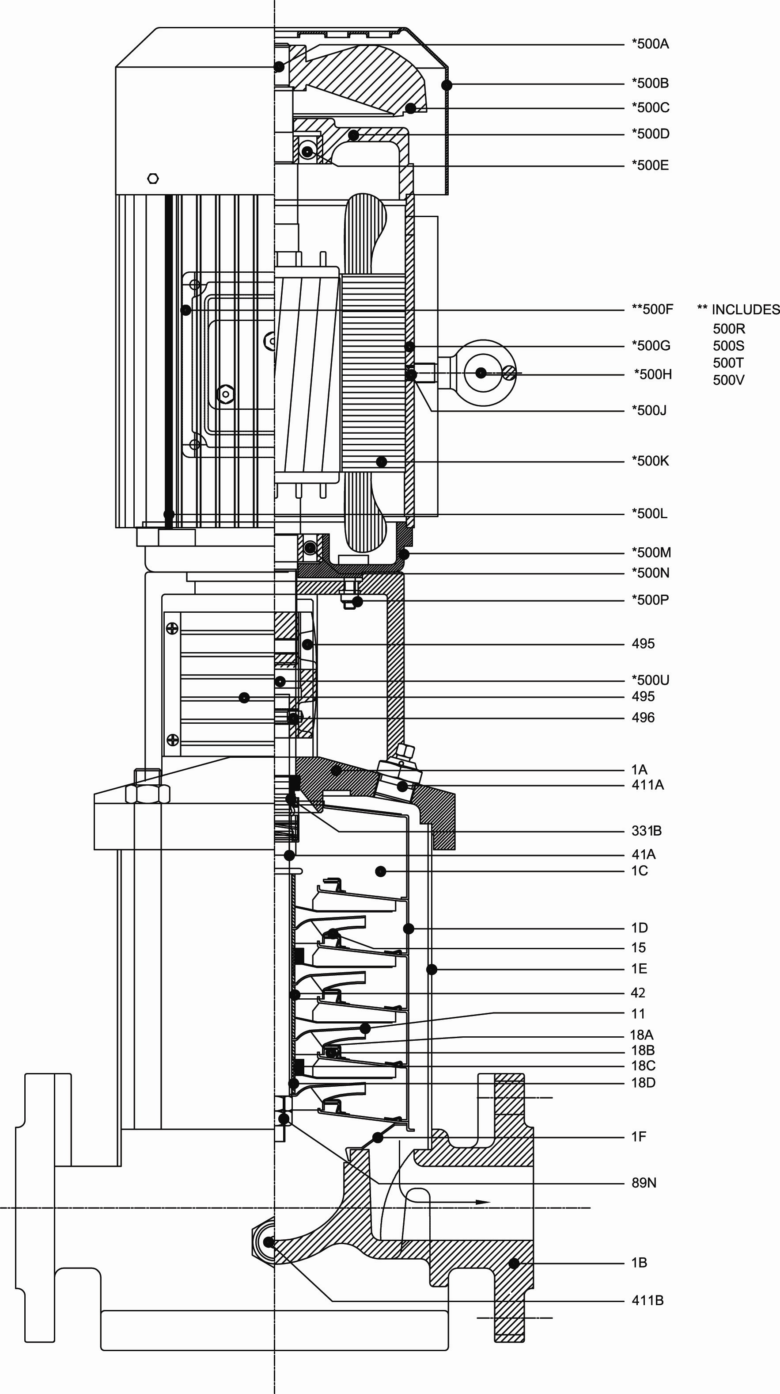
Item Number | Item Description | Num. Req.
1A | Top Pump Bracket | 1
1B | Bottom Pump Bracket | 1
1C | Pump Casing | 1
1D | Casing Stage | Varies
1E | Pump Outer Shell | 1
1F | Suction Casing | 1
11 | Impeller | Varies
15 | Case Wear Ring | Varies
18A | Upper Guide Bearing | Varies
18B | Lower Guide Bearing | Varies
18C | Casing Bearing | Varies
18D | Guide Bearing | 1
41A | Shaft | 1
42 | Shaft Sleeve | 1
89N | Locknut | 1
331B | Mechanical Seal | 1
411A | Vent Plug | 1
411B | Drain Plug | 1
490 | Split Coupling | 1
495 | Coupling Guard | 1
496 | Coupling Split Pin | 1
*500A | Motor Cooling Fan Split Pin | 1
*500B | Motor Cooling Fan Cover | 1
*500C | Motor Cooling Fan | 1
*500D | Motor Outboard Cover | 1
*500E | Motor Outboard Bearing | 1
*500F | Motor Terminal Box | 1
*500G | Motor Frame | 1
*500H | Motor Lifting Eye
*500J | Motor Eye Bolt Set Screw | 1
*500K | Motor Stator Windings | 1
*500L | Motor Tie Rod With Nut | 4
*500M | Motor Front Cover | 1
*500N | Motor Inboard Bearing | 1
*500P | Motor Stud | 4
*500R | Motor Capacitor | 1
*500S | Motor Top Cover | 1
*500T | Motor Bottom Cover | 1
*500U | Motor Shaft & Rotor | 1
*500V | Motor Terminal Board | 1
*American-Marsh motor item.
Recommended spare parts are in BOLD.

